**Docker Volume Driver Plugin Models**

Friday, December 11, 2015

11:53 AM

[Docker Volume Plugin](https://blog.docker.com/2015/06/extending-docker-with-plugins/) opens a flood gate of innovations. In my rough categorization, the following two models summarize current development status.

**Model 1**

[volume-driver](https://huaminchen.files.wordpress.com/2015/08/volume-driver.png)

In this model, you’ll find volume drivers directly connected to filesystems. Containers can use the backend filesystems for data persistence. No more magic beyond what the backends can provide.

**Model 2**

[volume-manager](https://huaminchen.files.wordpress.com/2015/08/volume-manager.png)

Examples in this model include [Flocker](https://github.com/ClusterHQ/flocker), [Convoy](https://github.com/rancher/convoy), [RexRay](https://github.com/emccode/rexray). Value added volume managers virtualize the backend filesystems. They can provide data services such as migration, snapshot, backup, etc.

* + Case #1: Storing data within the container
  + Case #2: Store your data outside Docker’s Union Filesystem
  + Case #3: Mounting a volume within the Docker host’s filesystem
  + Case #4: Storing data on a network-attached block device using the Flocker plug-in for Docker via --volume-driverflag

Flocker

[Installing the Flocker Client](https://docs.clusterhq.com/en/1.8.0/install/install-client.html)

* + [Installing the Flocker Node Services](https://docs.clusterhq.com/en/1.8.0/install/install-node.html)

* + [Configuring Cluster Authentication](https://docs.clusterhq.com/en/1.8.0/config/configuring-authentication.html)

* + [Generating an API User Certificate](https://docs.clusterhq.com/en/1.8.0/config/generate-api-certificates.html)

* + Installing the Flocker Plugin for Docker

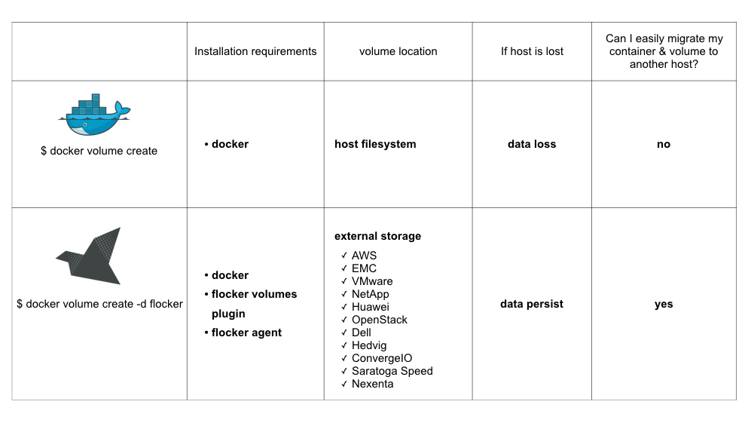

Convoy

* + install and configure Convoy volume plugin
  + data and metadata device setup
  + take a snapshot of the convoy volume
  + The convoy backup command returns a URL string representing backup dataset. You can use the same URL string to recover the volume to another host
  + creates a new container and mounts the recovered convoy volume into that container:

* + The [Convoy plugin](https://github.com/rancher/convoy) is a volume plugin for a variety of storage back-ends including device mapper and NFS. It’s a simple standalone executable written in Go and provides the framework to support vendor-specific extensions such as snapshots, backups and restore.

* + The [Flocker plugin](https://clusterhq.com/docker-plugin/) is a volume plugin which provides multi-host portable volumes for Docker, enabling you to run databases and other stateful containers and move them around across a cluster of machines.

* + The [GlusterFS plugin](https://github.com/calavera/docker-volume-glusterfs) is another volume plugin that provides multi-host volumes management for Docker using GlusterFS.

**Why we need Convoy?**

Docker has various drivers(aufs, device mapper, etc) for container's root image, but not for volumes. User can create volume through docker run -v volname, but it's disposable, cannot be easily reused for new containers or containers on the other hosts. For example, if you start a wordpress container with database, add some posts, remove the container, then the modified database would lost.

Before volume plugin, the only way to reuse the volume is using host bind mount feature of Docker, as docker run -v /host_path:/container_path, then maintain the content of the volume at /hostpath. You can also use --volume-from but that would require original container still exists on the same host.

Convoy used Docker volume plugin mechanism to provide persistent volume for Docker containers, and supports various of backends(e.g. device mapper, NFS, EBS) and more features like snapshot/backup/restore. So user would able to migrate the volumes between the hosts, share the same volume across the hosts, make scheduled snapshots of as well as recover to previous version of volume. It's much easier for user to manage data with Docker volumes with Convoy.